LIGHT – Study notes
Complete the following sentences and tasks to make a set of study notes on LIGHT and electromagnetic radiation
DEFINITIONS:  Click to write is just one form of Click to write radiation.  Click to write is made up of Click to write different colours.  The colours of visible light are (in order) from Click to write.  The law of Click to write states that the angle of Click to write is equal to the angle of Click to write  Click to write occurs when light travels at an angle through a Click to write object.  The electromagnetic spectrum is made of, in order from lowest to highest frequency; Click to write waves, Click to write waves, Click to write waves, Click to write light, Click to write waves, Click to write waves, and Click to write waves.  The Click to write of light in space is 300,000 Click to write |  |  | Complete the labels for this diagrams:  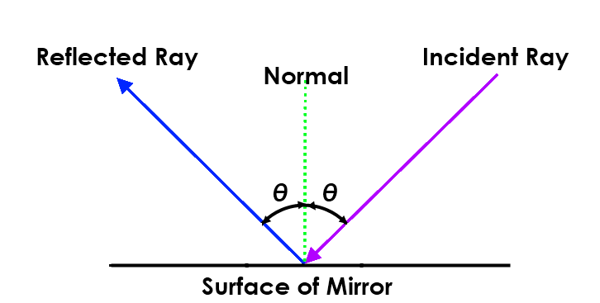  Angle of  Click to write  Angle of  Click to write  Click to write  Click to write  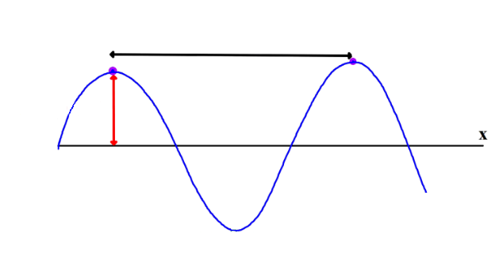  Click to write  Click to write  Use drawing tools to complete the rays of light on this diagram and draw in the angle of incidence and angle of refraction  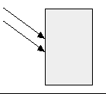 | 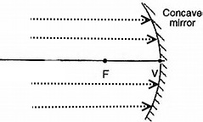  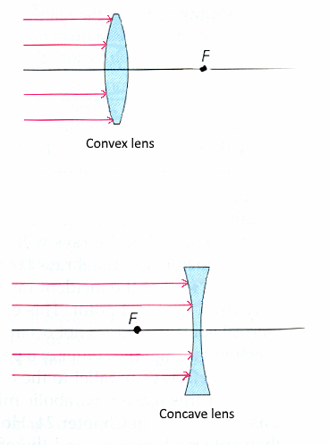  Use drawing tools to complete the rays of light on these diagram:  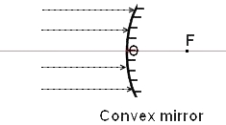
WORDS TO USE  Electromagnetic  Light  Yellow  Transparent  Refraction  Reflection  Infra-red  Km/hr  Incidence | incident  Light  Seven  Green  Violet  Radio  ultra-violet  Gamma ray  Speed  reflected | reflection  Orange  x-ray frequency  microwave  Red  indigo  Incident  blue  Reflection  Amplitude

